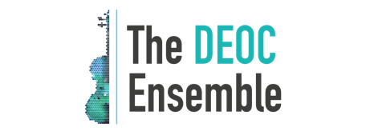
Music for Any Occasion

THE DEOC ENSEMBLE NAMED WINNER OF THE KNOT
BEST OF WEDDINGS 2020

Fourteenth Annual Best of Weddings Awards Honor
the Top Wedding Vendors Across America

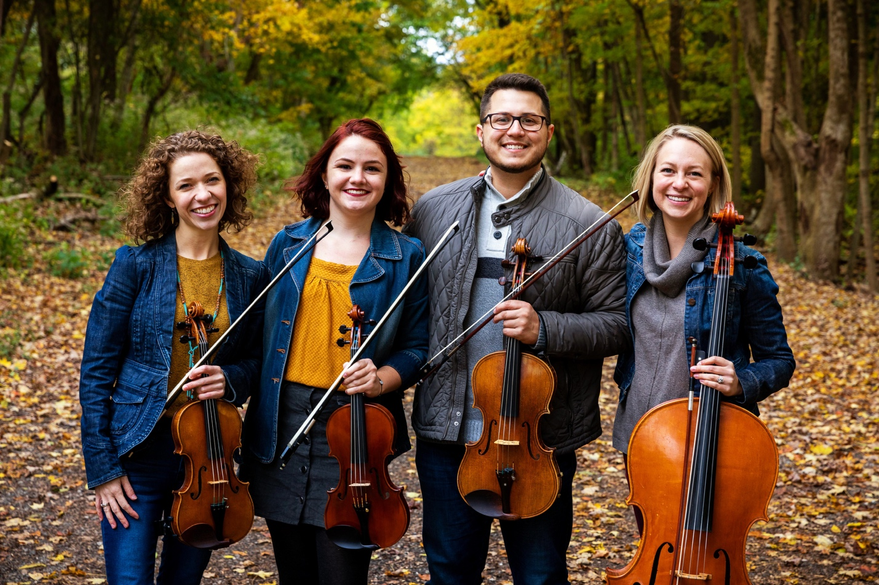
Photo by J.T. Smith Photography

Indianapolis, Indiana – The Deoc Ensemble is pleased to announce that they have been selected as a 2020 Winner of The Knot Best of Weddings, an accolade representing the highest and most-rated wedding professionals as reviewed by real couples, their families, and wedding guests on The Knot, a leading wedding planning brand and app. This is the second year The Deoc Ensemble has been named a winner of The Knot Best of Weddings awards.

In 2020, only five percent of hundreds of thousands of local wedding professionals listed on The Knot received this distinguished award. In its fourteenth annual year, The Knot continues its longstanding tradition of supporting local wedding vendors with The Knot Best of Weddings 2020, an annual by-couples, for-couples guide to the top wedding professionals across the country. To determine the winners, The Knot analyzed its millions of user reviews across various vendor categories, including venues, musicians, florists, photographers, caterers and more, to find the highest rated vendors of the year. These winners represent the best of the best wedding professionals that engaged couples should consider booking for their own unique wedding.

“Our entire team is thrilled to accept this prestigious award from The Knot for the second year in a row. We truly believe that we have the best jobs in the world – helping bring to life our clients’ unique visions for their special events and getting to know so many wonderful people along the way!”
Grace Meier
Co-Owner and Manager, The Deoc Ensemble

The Knot has inspired 25 million couples (and counting!) to plan a wedding that’s uniquely theirs. With a rich history of providing high-quality content and inspiration, The Knot makes it easy for couples to connect with and book the right wedding professionals to create their perfect wedding day. On The Knot Marketplace, couples can get connected to any of the hundreds of thousands of local wedding professionals across the country. The Knot Best of Weddings gives couples the confidence to find and book the best local vendors to bring their wedding visions to life. In combination with years of trusted content, The Knot’s innovative technology makes planning one’s wedding celebrations easier and more enjoyable.

Wedding professionals who win The Knot Best of Weddings are members of WeddingPro, the leading B2B wedding brand. As the largest marketplace and community for wedding professionals, WeddingPro connects businesses with more than 13 million visitors per month who are planning weddings on The Knot and WeddingWire, as well as with hundreds of thousands of pros in the industry. Through its online marketplaces, educational programs and community-building events, WeddingPro is dedicated to helping wedding professionals build relationships with couples and pros that grow their businesses.

For more information about The Knot Best of Weddings and this year’s winners, please visit https://www.theknot.com/vendors/best-of-weddings.

# # #

About The Deoc Ensemble
Since its founding in 2007, The Deoc Ensemble has provided live string music for more than 500 weddings and other special events in the Indianapolis, Indiana area. Fueled by a passion for all genres of music, co-founders Grace Meier and Sean Kilgore work to make sure that every event has the perfect soundtrack to bring each client’s unique vision to life. They offer a streamlined planning process that is completely customizable, including various ensemble sizes, repertoire lists with diverse styles and genres, a complimentary special request with affordable additional requests, and advice and suggestions along the way to make sure each event has the perfect touch of music.

Find out more at www.thedeocensemble.com and connect with Deoc on Facebook and Instagram.

About The Knot
The Knot is the nation’s leading multiplatform wedding resource offering a seamless, all-in-one planning experience—from finding inspiration and local vendors to creating and managing all guest experiences, wedding registries and more. The trusted brand reaches a majority of engaged couples in the US through the #1 wedding planning website TheKnot.com and #1 iOS and Android mobile app The Knot Wedding Planner, The Knot national and local wedding magazines, and The Knot book series. Since its inception, The Knot has inspired approximately 25 million couples to plan a wedding that’s uniquely them. Visit The Knot online at TheKnot.com and follow on social media: Facebook.com/TheKnot and @TheKnot on Twitter, Pinterest and Instagram.

###

PRESS CONTACT:
The Deoc Ensemble
Haley Stevenson
317-750-1809
haley@thedeocensemble.com

